NAME: _______________________________

Volleyball: Passing and Serving up Parabolas

- Two volleyball players are passing a volleyball back and forth over a net which is placed on the y axis
as shown below. The volleyball travels a parabolic path.
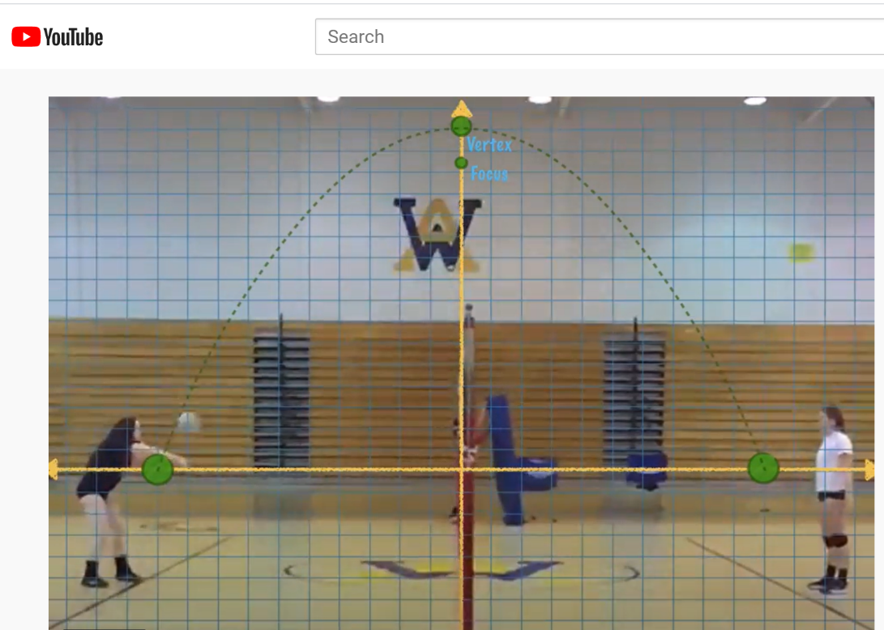

Image Source: Boitnott, Abby, “Parabola Volleyball Pass” (2016). https://youtu.be/mtAaZfbT9KY

- What is the vertex of the parabola?

- What are the zeros of this graph (write as ordered pairs)?

- Determine the quadratic function representing the parabolic path of the ball.

- Check your function by graphing using Desmos at: https://www.desmos.com/calculator/aw7arloafp

Attribution:
Problem #1 authored by Kelly Remijan. Located at: https://digitalcommons.imsa.edu/pfs_tr/9/

PAGE 2

- A volleyball player serves the ball across the court. We can model this situation with the function:
$$f\left(x\right)=-.006{(x-21)}^{2}+9$$
where x is the distance the ball is from the player and y is the height of the ball above the court.

- Graph the parabola using DESMOS.

- How high above the ground does the server hit the ball?

- What is the maximum height that the ball will reach after leaving the server’s hand?

- How far from the server does the ball reach its maximum height?

- If the volleyball net is 31 feet away from the server and the height of the net is 7' 4 1/8", does the volleyball clear the net?

Attribution:
Problem #2 from: CK-12. Located at: https://www.ck12.org/book/ck-12-elementary-and-intermediate-college-algebra/section/8.8/. License: https://creativecommons.org/licenses/by-nc/3.0/ with modifications made by Kelly Remijan.

