

Note: Lessons within this activity will be continued in the Capstone Project: Trip to Mars (Unit 6). Students should keep all materials from this unit to reference at the beginning of the project.

Key Concepts
Slope, linear equations, direct variation, independent and dependent variables, different representations of a function

Problem Duration
75 minutes

Technology
Computer with projector, scientific calculator

Materials
- Student Edition
- Exercising in Space Video

Degree of Difficulty
Moderate

Skills
Identify direct variation, determine slope, identify linear functions, write linear equations, solve linear equations, and create tables

NCTM Standards
- Number and Operations
- Algebra
- Problem Solving
- Communication
- Connections
- Representation

National Aeronautics and Space Administration

Exercising in Space
Modifications to this activity were made to update web links and extensions. Original activity may be located here.

Instructional Objectives
The 5-E’s Instructional Model (Engage, Explore, Explain, Extend, Evaluate) will be used to accomplish the following objectives.
Students will:
- identify direct variation from ordered pairs by calculating the constant of variation;
- calculate slope from two points using the slope formula;
- determine independent and dependent variables;
- solve linear equations; and
- create tables.

Prerequisites
Students should have prior knowledge of direct variation, the constant of variation, linear functions, different representations of a linear function, the properties of a linear function, calculating slope, and solving linear equations.

Background
This problem is part of a series that applies algebraic principles in NASA’s human spaceflight.
The Biomedical Engineer (BME) flight controller is part of the medical operations team. She/he supports the Flight Surgeon and is the medical hardware expert. On the ISS that hardware includes the Crew Health Care System and its subsystems: the Health Maintenance System, the Environmental Health System, and the Countermeasure System.

Astronauts orbiting Earth aboard the space shuttle or the ISS do not feel the effects of gravity as we do on Earth. In this reduced gravity state, it is
easier to accomplish routine activities and requires little use of muscles. Since minimal to no exercise would result in muscle deterioration and bone density loss, astronauts are prescribed exercise routines by exercise and rehabilitation specialists and medical doctors. Astronauts are scheduled to exercise approximately 2 hours per day while on the ISS. Exercise is an example of what is called a “countermeasure”. It is used to prevent or counter the physical symptoms that might otherwise occur. Exercise is an essential part of every astronaut’s health maintenance.

www.nasa.gov Exercising in Space 1/10

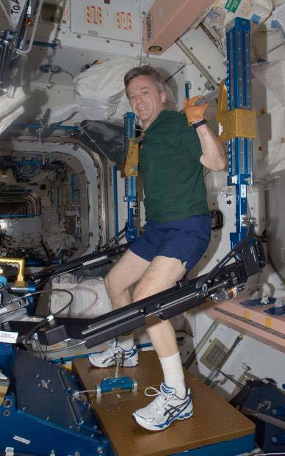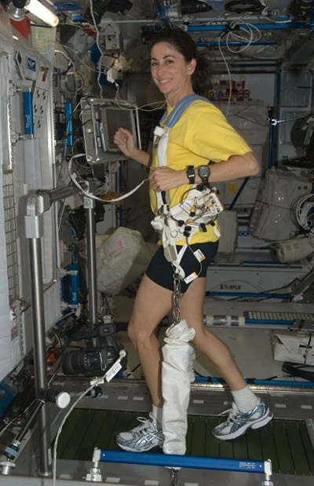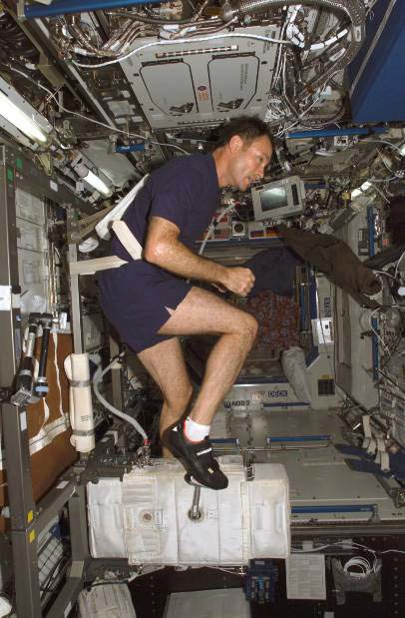

Figure 1: Astronaut Robert Thirsk uses ARED while onboard the ISS.
Figure 2: Astronaut Nicole Stott uses T2 while onboard the ISS.
Figure 3: Astronaut Michael E. Lopez-Alegria uses CEVIS while onboard the ISS.

Numerous types of exercise equipment have been used in reduced gravity to evaluate and maintain astronaut fitness. Currently, astronauts use the Advanced Resistive Exercise Device (ARED) on the ISS to perform resistance exercises (Figure 1). Treadmill 2 (T2), also known as COLBERT, is a second generation treadmill that is used as one of the countermeasures to help prevent bone loss on long duration missions aboard the ISS (Figure 2). Like its predecessor, Treadmill with Vibration Isolation and Stabilization (TVIS), T2 is suspended and contained within an opening in the floor to minimize the forces of exercise being transferred to the structure of the ISS.
The Cycle Ergometer with Vibration Isolation Stabilization (CEVIS) is similar to a stationary mechanical bicycle and is connected to the ISS with wire tethers. It also sits on a vibration isolation system which reduces impacts to the structure of the ISS (Figure 3). Astronauts snap their shoes onto the pedals and use a seatbelt to hold them on the bicycle. They can change the workload (the force with which they must push on the pedals) to maximize their workout. The speed is also adjusted to keep the astronaut’s heart rate at a specific target which is tracked with a heart rate monitor.
The BME flight controller provides procedures for activities such as maintenance, repair, and regular use of this equipment. When something does not go as planned or the crew needs clarification regarding the hardware, the BME is available to relay any needed adjustments.
With the assistance of the BME, the exercise specialist, the medical doctor, and the exercise equipment provided on the ISS, astronauts are able to maintain their fitness while on exploration missions. This allows them to perform mission objectives and, hopefully, return to Earth without serious health complications.

NCTM Principles and Standards

Algebra
  - Understand relations and functions and select, convert flexibly among, and use various representations of them.

  - Write equivalent forms of equations, inequalities, and systems of equations and solve them with fluency – mentally or with paper and pencil simple cases and using technology in all cases.
  - Use symbolic algebra to represent and explain mathematical relationships.

Problem Solving
  - Solve problems that arise in mathematics and in other contexts.
  - Apply and adapt a variety of appropriate strategies to solve problems.

Communication
  - Organize and consolidate their mathematical thinking through communication.
  - Communicate their mathematical thinking coherently and clearly to peers, teachers, and others.
  - Analyze and evaluate the mathematical thinking and strategies of others.
  - Use the language of mathematics to express mathematical ideas precisely.

Connections
  - Recognize and use connections among mathematical ideas.
  - Recognize and apply mathematics in contexts outside of mathematics.

Representation
  - Select, apply, and translate among mathematical representations to solve problems.

Lesson Development
Following are the phases of the 5-E’s model in which students can construct new learning based on prior knowledge and experiences. The time allotted for each activity is approximate. Depending on class length, the lesson may be broken into multiple class periods.

- – Engage (15 minutes)
  - There are a number of videos about exercising in space including an overview, and information about cycling, running and weight lifting. Play the video, Exercise.
  - Have students read the Background section and compose 1-2 brief summary statements from the reading.

- – Explore (15 minutes)
  - Distribute the worksheet, CEVIS: Space Bike.
  - Have students work as a class answering questions 1 and 2 cooperatively.
  - Ask students to share their answers with the class, and encourage student discussion.

- – Explain (20 minutes)
  - On the worksheet, CEVIS: Space Bike, have students work in small groups answering questions 3 – 8 cooperatively.
  - Ask students to share their answers with the class, and encourage student discussion.

- – Extend (25 minutes) Capstone Project: Trip to Mars
  - On the worksheet, CEVIS: Space Bike, have students work on questions 9 – 14 independently.
  - Ask students to share their answers with the class, and encourage student discussion.

- – Evaluate (15 minutes) Capstone Project: Trip to Mars
  - On the worksheet, CEVIS: Space Bike, have students complete questions 15 – 17 independently. This may be done in class or assigned as homework.

ENGAGE
Video: Exercising in Space
  - After viewing Exercise, discuss with the students some of the differences between exercising in space and on Earth. Encourage students to make conjectures based on what they know about exercising on Earth and what they think would happen in space. Some of the conjectures may not be correct, but don’t worry about correcting them at this point in the lesson. Some possible items for students to consider would be:
    - How does gravity affect a person when they exercise on Earth?
    - Why is exercise in space necessary for astronauts?
    - What modifications might need to be made to exercise equipment in order to be used in reduced gravity?
    - What are some other things that might be different about exercising in reduced gravity?
  - After students read the Background section together in their groups and compose 1-2 brief summary statements, have each group share their summaries with the class. Encourage student discussion on the video and the Background section. Revisit the conjectures students made discussing which ones were correct and which were not.

EXPLORE

CEVIS: Space Bike

Solution Key

Directions: Show all work and justify your answers to the questions below. Include units. Round all answers to the nearest tenth unless otherwise indicated.

Party of the daily routine of a crew member on the ISS is to exercise. CEVIS, the exercise bike, has a control panel with loaded protocols to increase and decrease the loads, but if it fails, astronauts control the settings with a less sophisticated back-up display. Astronauts have reference cards that show the settings for adjusting the controls according to the prescriptions given to them by the medical doctor.
Astronauts and medical and exercise specialists need to understand algebra.

Suppose an astronaut looks at his prescription and finds that he has been asked to move to a new voltage and power on CEVIS. Table 1 shows the information provided on the reference cards to adjust the CEVIS’s power. The astronaut must first change the voltage setting by turning the voltage knob.

Table 1: CEVIS Voltage vs. Power

Voltage, V (volts) | Power, P (watts)
0.6 | 25
1.2 | 50
3.0 | 125
4.8 | 200
5.4 | 225
6.6 | 275
8.4 | 350

- Explore the data in Table 1. How are the values of the voltage and power changing? Can you find a relationship between the Voltage values and the Power values? Do the data points represent a function? Why or why not?

Both the values of Voltage and Power are increasing. But they are changing by different amounts. A relationship cannot be found by looking at the data. Since for every V, there is exactly one P, the data points represent a function.

- Which variable in Table 1 is independent and which variable is dependent? Explain your answer.

The voltage is the input therefore it is independent. Power depends on the voltage, therefore it is dependent.

Note: Remind students that the independent and dependent variables are not always labeled x and y, but may be letters that better represent the variables being studied. Varying the independent variable x (or as in this example, V) results in a change in the dependent variable y (or as in this example, P).

EXPLAIN

Solution Key

Directions: Answer questions 3 – 8 in your group. Discuss answers to be sure everyone understands and agrees on the solutions. Include units. Round all answers to the nearest tenth unless otherwise indicated.

- Test each ordered pair in Table 1 for constant variation. Use the constant variation
equation, k =$\frac{y}{x}$ . Determine if the function in Table 1 is a direct variation relationship. Explain
your reasoning.

Using k = y
x
students should get the following results: 25 watts = 41.7 watts per volt ,
0.6 volts

50 watts = 41.7 watts per volt , 125 watts = 41.7 watts per volt ,
1.2 volts 3.0 volts

200 watts = 41.7 watts per volt , 225 watts = 41.7 watts per volt ,
4.8 volts 5.4 volts

275 watts = 41.7 watts per volt , 350 watts = 41.7 watts per volt
6.6 volts 8.4 volts
Since the constant of variation is 41.7 watts per volt for all the ordered pairs, the function shows a direct variation relationship.

- Is the function in Table 1 linear or non-linear? Explain your answer.

It is linear because it has a constant rate of change.

- What is the slope of the function represented in Table 1? Label the units of the slope. Explain what the slope represents in this problem situation.

m = y 2 − y1
x2 − x1
m = 50 − 25 difference in watts
  - − 0.6 difference in volts

m = 41.7 watts per volt

For every volt changed on the voltage, the power increases by 41.7 watts.

- How are the slope and the constant of variation related in questions 3 and 5?

They are the same.

- Write the linear equation that represents the information in Table 1. Use V for voltage and P for the power in watts. What is the vertical intercept? Interpret this in the context of the problem.

P = 41.7 V
The vertical intercept is 0. The initial voltage setting on the control panel is 0.

Note: Instructors may ask students to graph this linear relationship using an online graphing tool or piece of graph paper.

- Another astronaut has been prescribed a power of 150 watts. Her reference card (Table 1) does not show this voltage. The BME flight controller in the MCC is asked to inform the astronaut of the new voltage. What voltage is required to achieve 150 watts?

150 watts = 41.7 V
150 = V
41.7
3.6 = V , the volts needed for a power of 150 watts.

EXTEND Part of this section will be completed during the Capstone Project: Trip to Mars

Solution Key

Directions: Answer questions 9 – 14 independently. Include units. Round all answers to the nearest tenth unless otherwise indicated.

An astronaut’s prescription also included a change in speed on CEVIS. In order to adjust the speed in rotations per minute (RPM) the voltage knob is turned. Table 2 contains given voltage V (volts) and the resulting speed S (RPM).
Note: Bold entries in a column of a table indicate answers, and are left blank in the Student Edition.

Table 2: Voltage vs. Speed

Voltage, V (volts) | Speed, S (RPM) | k (RPM per volt)
2 | 30 | 15
3 | 45 | 15
5 | 75 | 15

- Test each ordered pair in the Table 2 for constant variation. Use the constant variation equation
k = y . Enter the values of k in Table 1. Determine if the function in Table 2 is a direct variation
x
relationship. Explain your reasoning.

Using k = y
x

students should get the following results.

30 RPM = 15 RPM per volt , 45 RPM = 15 RPM per volt , 75 RPM = 15 RPM per volt

- volts
- volts
5 volts

The function is a direct variation relationship since the constant of variation is the same (15 RPM per volt) for each ordered pair.

- What is the slope of the function represented in Table 2? Include units for the slope. Explain what slope represents in this problem situation.

m = y 2 − y1
x2 − x1
m = 75 − 30 difference in RPM 5 − 2 difference in volts

m = 15 RPM per volt

Slope, m, (or constant of variation, k) means for every increase of 1 volt, the speed increases by 15 RPM.

- Write the linear equation that represents the information in Table 2. Use V for the voltage in volts and S for speed in RPM.

S = 15 V

Note: Instructors may require students to graphically represent this linear equation using an online graphing tool or piece of graph paper.

The remaining questions and sections should be completed during the Capstone Project: Trip to Mars. Students should keep all work to reference again at the beginning of the project.

- The astronaut is advised to make an adjustment on CEVIS to a new speed of 105 RPM. The reference card does not show this setting. What voltage is required to achieve 105 RPM?

k = 15 RPM per volt 105 RPM = 15 V
105 = V
15
7 = V , the volts needed to reach 105 RPM.

- Suppose that for every increase in the voltage of 1.3 volts, the speed increases by 24 RPM. Find the constant of variation.

k = 24 RPM
  - volts
k = 18.5 , the constant of variation.

- Using the constant of variation found in question 13, write an equation in S and V to represent this relationship. If the RPM required is 62, find the setting in volts, V.

S = 18.5 V
62 = 18.5 V
62 = V
18.5
3.4 = V, the voltage setting to reach 62 RPM.

EVALUATE Capstone Project: Trip to Mars

Solution Key

Directions: Complete questions 15 – 17 independently. Include units. Round all answers to the nearest tenth unless otherwise indicated.

Table 3 shows the first three entries of the reference card for setting the power on CEVIS. Use constant variation rules to answer questions 15 – 16.

Table 3: CEVIS Voltage vs. Power

Voltage, V (volts) | Power, P (watts)
0.6 | 25
1.2 | 50
1.8 | 75

15. If an astronaut adjusts the voltage of CEVIS to 7.2 volts, what would the resulting power be in watts? Round power to the nearest whole number.

k = y
x

k = 25 watts
0.6 volts

k = 41.7 watts per volt
41.7 = P
7.2

P = 300 watts, power resulting from 7.2 volts.

16. What voltage would be required to reach a power of 100 watts?

41.7 watts per volt = 100 watts
V
41.7 V = 100
V = 2.4 volts required to reach a power of 100 watts.

17. Table 4 shows the values that are listed on the reference card for the speed of CEVIS. The constant of variation for these settings is 15 RPM per volt. Use the constant variation rules to fill in the voltages in the first column of the table.
The solution for the first two values is shown below. Students should continue to follow this procedure for the remaining values or they may see that they are simply dividing S (RPM) by the constant of variation 15 RPM per volt to arrive at the voltage, V.

15 RPM per volt = 40 RPM
V
15 V = 40
V = 2.7 volts to reach 40 RPM.

15 RPM per volt = 50 RPM
V
15 V = 50
V = 3.3 volts to reach 50 RPM.

Table 4: Voltage vs. Speed
Voltage, V (volts) | Speed, S (RPM)
2.7 | 40
3.3 | 50
4.0 | 60
4.7 | 70
5.3 | 80
6.0 | 90
6.7 | 100

Contributors
This problem was developed by the Human Research Program Education and Outreach (HRPEO) team with the help of NASA subject matter experts and high school mathematics educators.
Modifications to this activity were made to update web links. Original activity at https://www.nasa.gov/audience/foreducators/exploringmath/algebra1/Prob_Exercise_detail.html

NASA Experts
Kevin Rosenquist, BME Flight Controller/Instructor, ISS Mission Control Center, NASA Johnson Space Center
Lori Ploutz-Snyder, PhD, Project Scientist & Lab Lead, Exercise Physiology and Countermeasures, NASA Johnson Space Center

Mathematics Educator
Paulette Granger, J. Frank Dobie High School, Pasadena Independent School District

