
National Aeronautics and Space Administration



Exercising in Space

Background
This problem is part of a series that applies algebraic principles in NASA’s human spaceflight.
The Biomedical Engineer (BME) flight controller is part of the medical operations team for the ISS. The BME supports the Flight Surgeon and is the medical hardware expert. On the ISS that hardware includes the Crew Health Care System and its subsystems: the Health Maintenance System, the Environmental Health System, and the Countermeasure System.
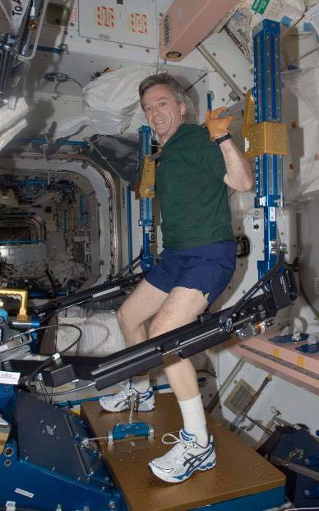
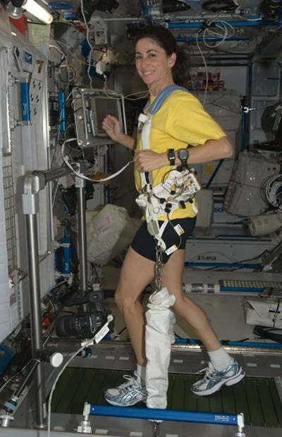
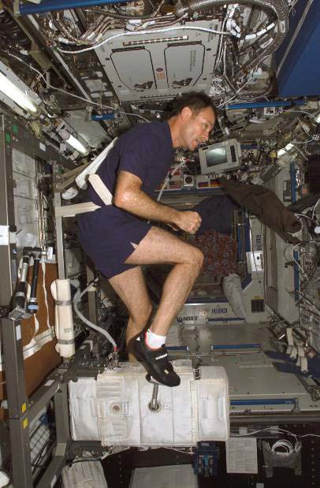

Figure 1: Astronaut Robert Thirsk uses ARED while onboard the ISS.
Figure 2: Astronaut Nicole Stott uses T2 while onboard the ISS.
Figure 3: Astronaut Michael E. Lopez-Alegria uses CEVIS while onboard the ISS.

Astronauts orbiting Earth aboard the space shuttle or the ISS do not feel the effects of gravity as we do on Earth. In this reduced gravity state, it is easier to accomplish routine activities and requires little use of muscles. Since minimal to no exercise would result in muscle deterioration and bone density loss, astronauts are prescribed exercise routines by exercise and rehabilitation specialists and medical doctors. Astronauts are scheduled to exercise approximately 2 hours per day while on the ISS.

Exercise is an example of what is called a “countermeasure”. It is used to prevent or counter the physical symptoms that might otherwise occur. Exercise is an essential part of every astronaut’s health maintenance.
Numerous types of exercise equipment have been used in reduced gravity to evaluate and maintain astronaut fitness. Currently, astronauts use the Advanced Resistive Exercise Device (ARED) on the ISS to perform resistance exercises (Figure 1). Treadmill 2 (T2), also known as COLBERT, is a second generation treadmill that is used as one of the countermeasures to help prevent bone loss on long duration missions aboard the ISS (Figure 2). Like its predecessor, Treadmill with Vibration Isolation and Stabilization (TVIS), T2 is suspended and contained within an opening in the floor to minimize the forces of exercise being transferred to the structure of the ISS.
The Cycle Ergometer with Vibration Isolation Stabilization (CEVIS) is similar to a stationary mechanical bicycle and is connected to the ISS with wire tethers. It also sits on a vibration isolation system which reduces impacts to the structure of the ISS (Figure 3). Astronauts snap their shoes onto the pedals and use a seatbelt to hold them on the bicycle. They can change the workload (the force with which they must push on the pedals) to maximize their workout. The speed is also adjusted to keep the astronaut’s heart rate at a specific target which is tracked with a heart rate monitor.
The BME flight controller provides procedures for activities such as maintenance, repair, and regular use of this equipment. When something does not go as planned or the crew needs clarification regarding the hardware, the BME is available to relay any needed adjustments.
With the assistance of the BME, the exercise specialist, the medical doctor, and the exercise equipment provided on the ISS, astronauts are able to maintain their fitness while on exploration missions. This allows them to perform mission objectives and, hopefully, return to Earth without serious health complications.

Instructional Objectives
- You will identify direct variation from ordered pairs by calculating the constant of variation;
- You will calculate slope from two points using slope formula;
- You will determine independent and dependent variables;
- You will solve linear equations; and
- You will create tables.

CEVIS: Space Bike

Directions: Show all work and justify your answers to the questions below. Include units. Round all answers to the nearest tenth unless otherwise indicated.

Problem
Part of the daily routine of a crew member on the ISS is to exercise. CEVIS, the exercise bike, has a control panel with loaded protocols to increase and decrease the loads, but if it fails, astronauts control the settings with a less sophisticated back-up display. Astronauts have reference cards that show the settings for adjusting the controls according to the prescriptions given to them by the medical doctor.
Suppose an astronaut looks at his prescription and finds that he has been asked to move to a new voltage and power on CEVIS. Table 1 shows the information provided on the reference cards to adjust the CEVIS’s power. The astronaut must first change the voltage setting by turning the voltage knob.

Table 1: CEVIS Voltage vs. Power

Voltage, V (volts) | Power, P (watts)
0.6 | 25
1.2 | 50
3.0 | 125
4.8 | 200
5.4 | 225
6.6 | 275
8.4 | 350

- Explore the data in Table 1. How are the values of the voltage and power changing? Can you find a relationship between the Voltage values and the Power values? Do the data points represent a function? Why or why not?

- Which variable in Table 1 is independent and which variable is dependent? Explain your answer.

Directions: Answer questions 3 – 8 in your group. Discuss answers to be sure everyone understands and agrees on the solutions. Include units. Round all answers to the nearest tenth unless otherwise indicated.

- Test each ordered pair in Table 1 for constant variation. Use the constant variation
equation, k = y . Determine if the function in Table 1 is a direct variation relationship. Explain
x
your reasoning.

- Is the function in Table 1 linear or non-linear? Explain your answer.

- What is the slope of the function represented in Table 1? Label the units of the slope. Explain what the slope represents in this problem situation.

- How are the slope and the constant of variation related in questions 3 and 5?

- Write the linear equation that represents the information in Table 1. Use V for voltage and P for the power in watts. What is the vertical intercept? Interpret this in the context of the problem.

- Another astronaut has been prescribed a workload of 150 watts. Her reference card (Table 1) does not show this setting. BME flight controller in the MCC is asked to inform the crew member of the new setting. What voltage setting is required to achieve 150 watts?

Directions: Answer questions 9 – 14 independently. Include units. Round all answers to the nearest tenth unless otherwise indicated.

An astronaut’s prescription also included a change in speed on CEVIS. In order to adjust the speed in rotations per minute (RPM) the voltage knob is turned. Table 2 contains given voltage V (volts) and the resulting speed S (RPM).
Table 2: Voltage vs. Speed

Voltage, V (volts) | Speed, S (RPM) | k (RPM per volt)
2 | 30
3 | 45
5 | 75

- Test each ordered pair in the Table 2 for constant variation. Use the constant variation equation
k = y . Enter the values of k in Table 1. Determine if the function in Table 2 is a direct variation
x
relationship. Explain your reasoning.

- What is the slope of the function represented in Table 2? Include units for the slope. Explain what slope represents in this problem situation.

- Write the linear equation that represents the information in Table 2. Use V for the voltage in volts and S for speed in RPM.

Note: This linear equation may be graphed using an online graphing tool or graph paper.

The following questions will be completed during the Capstone Project: Trip to Mars
- The astronaut is advised to make an adjustment on CEVIS to a new speed of 105 RPM. The reference card does not show this setting. What voltage is required to achieve 105 RPM?

- Suppose that for every increase in the voltage of 1.3 volts, the speed increases by 24 RPM. Find the constant of variation.

- Using the constant of variation found in question 13, write an equation in S and V to represent this relationship. If the RPM required is 62, find the setting in volts, V.

Directions: Complete questions 15 – 17 independently. Include units. Round all answers to the nearest tenth unless otherwise indicated.

Table 3 shows the first three entries of the reference card for setting the workload on CEVIS. Use constant variation rules to answer questions 15 – 16.

Table 3: CEVIS Voltage vs. Power

Voltage, V (volts) | Power, P (watts)
0.6 | 25
1.2 | 50
1.8 | 75

- If an astronaut adjusts the voltage of CEVIS to 7.2 volts, what would the resulting power be in watts? Round power to the nearest whole number.

- What voltage would be required to reach a power of 100 watts?

- Table 4 shows the values that are listed on the reference card for the speed of CEVIS. The constant of variation for these settings is 15 RPM per volt. Use the constant variation rules to fill in the voltages in the first column of the table.

Table 4: Voltage vs. Speed

Voltage, V (volts) | Speed, S (RPM)
 | 40
 | 50
 | 60
 | 70
 | 80
 | 90
 | 100

