

Note: Lessons within this activity will be continued in the Capstone Project: Trip to Mars (Unit 6). Students should keep all materials from this unit to reference at the beginning of the project.

Key Concept
Linear Equations and Functions

Problem Duration
90 minutes

Technology
Graphing calculator, computer with projector

Materials
- Student Edition
- Video: Bone Loss in Space

Degree of Difficulty
Moderate

Skills
Create tables, identify slope and y-intercept, write linear equations in slope intercept form, and solve equations

NCTM Standards
- Number and Operations
- Algebra
- Problem Solving
- Communication
- Connections
- Representations


National Aeronautics and Space Administration

Lost in Space: Bone Density
Modifications to this activity were made to update web links and extensions. Original activity may be located here.

Instructional Objectives
The 5-E’s Instructional Model (Engage, Explore, Explain, Extend, Evaluate) will be used to accomplish the following objectives.
Students will:
- explore slope and the effects of a change of slope;
- recognize slope and y-intercept from key words;
- identify the y-intercept and interpret its meaning in a real world situation;
- write linear equations in slope-intercept form;
- calculate values using percent and proportional relationships;
- solve linear equations; and
- create tables from words.

Prerequisites
Students should have prior knowledge of functions, different representations of a linear function, properties of a linear function, and slope intercept form.

Background
This problem is part of a series that applies algebraic principles in NASA’s human spaceflight.
The International Space Station (ISS) Control Center uses some of the most sophisticated technology and communication equipment in the world. Teams of highly qualified engineers, scientists, doctors, and technicians, known as flight controllers, monitor the systems and activities aboard the space shuttle and the ISS. They work together as a powerful team, spending many hours performing critical simulations as they prepare to support each mission and crew during normal operations and any unexpected events.
One of the flight control positions is the flight surgeon, whose call sign is SURGEON. The flight surgeon is a medical doctor who monitors and maintains the astronauts’ health during all phases of a particular mission, including spacewalks. The flight surgeon also monitors the astronauts’ scheduled activities, coordinates the medical operations team, provides crew health consultations during the mission, and advises the Flight Director of the crew’s health.

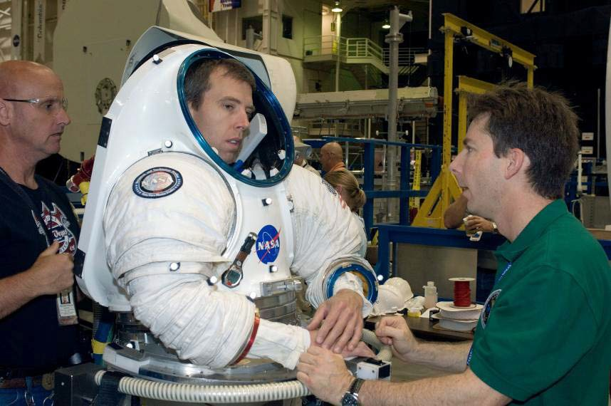
Figure 1: NASA Surgeon, Dr. Jeff Jones (right), and suit technician, Bill Welch (left), assist Astronaut, Andrew J. (Drew) Feustel, as he dons a Mark III advanced space suit.

Because spaceflight is physically challenging, the flight surgeon will assess the astronaut’s health before a flight, also known as preflight, to determine if the crew member is healthy. During the preflight phase of a mission, the flight surgeon will perform a physical examination of the astronaut. He or she will use pre-existing data to determine the astronaut’s preflight condition and to predict how the astronaut’s body will react in a reduced gravity environment.
One specific area of concern is bone density, which is a measure of how strong the bone is. Bone density is measured by the amount of mineral in a skeletal area, and this measurement is called Bone Mineral Density (BMD). BMD is measured with an instrument called a Dual-energy X-ray Absorptiometry densitometer (DXA), which uses x-rays to transmit photons through the body. DXA detects the different energies of the photons as they are absorbed differently by hard vs. soft tissue.
These energy levels are used to determine the BMD of hard bone tissue. Different groups of people lose BMD more rapidly than others. On Earth the rate of bone loss for elderly men and women ranges from 1% to 1.5% per year, whereas the rate of bone loss for an early postmenopausal woman could be 2-3% per year. A person may also lose BMD more rapidly at one site, e.g. the spine, than at another site in the body.
Bone loss increases when the human body is in a reduced gravity environment. Astronauts on the ISS, or on a future long-duration mission, may lose an average of 1% BMD per month while in space. An astronaut’s bones may weaken in a way similar to osteoporosis. Osteoporosis is a condition in which bones have lost minerals, especially calcium, making them weaker, more brittle, and susceptible to fractures. The risk of fracture for an astronaut may increase after the astronaut returns to Earth’s gravitational pull of1 g. The flight surgeon must continue to monitor the astronauts once back on Earth to make sure their BMD is regained through proper diet and exercise.

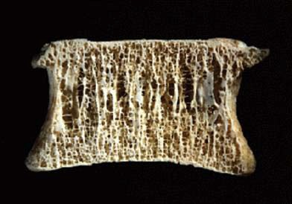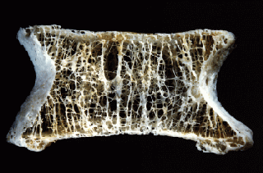
Source: Mosekilde, L. Z rheumatol 2000;59:Suppl 1:1-9
Figure 1: Normal bone on left compared to osteoporotic bone.

NCTM Principles and Standards

Number and Operations
  - Develop a deeper understanding of very large and very small numbers and of various representations of them.

Algebra
  - Generalize patterns using explicitly defined and recursively defined functions.
  - Understand relations and functions and select, convert flexibly among, and use various representations of them.
  - Understand the meaning of equivalent forms of expressions, equations, inequalities, and relations.
  - Write equivalent forms of equations, inequalities, and systems of equations and solve them with fluency – mentally or with paper and pencil in simple cases and using technology in all cases.
  - Use symbolic algebra to represent and explain mathematical relationships.

Problem Solving
  - Solve problems that arise in mathematics and in other contexts.
  - Apply and adapt a variety of appropriate strategies to solve problems.

Communication
  - Communicate their mathematical thinking coherently and clearly to peers, teachers, and others.
  - Use the language of mathematics to express mathematical ideas precisely.

Connections
  - Recognize and use connections among mathematical ideas.
  - Recognize and apply mathematics in contexts outside of mathematics.

Representations
  - Select, apply, and translate among mathematical representations to solve problems.

Lesson Development
Following are the phases of the 5-E’s model in which students can construct new learning based on prior knowledge and experiences. The time allotted for each activity is approximate. Depending on class length, the lesson may be broken into multiple class periods.

- – Engage – (15 minutes)
  - Play the video, Exercise Helps Keep Astronauts Healthy in Space (2.5 min).
  - Have students read the Background section together in their groups and compose 1-2 brief summary statements from their reading. Ask students to sketch two examples of BMD loss.

- – Explore – (20 minutes)
  - Distribute the worksheet, Comparing Bone Loss on Earth and the ISS.
  - Arrange students in groups of 3-4 and have them work through questions 1-6 as a group.
  - Ask students to share their answers with the class and encourage student discussion.

- – Explain – (20 minutes)
  - On the worksheet, Comparing Bone Loss on Earth and the ISS, have students continue to work as a group through questions 7-13.
  - Facilitate student discussion and answer questions.
  - Ask students to share their answers with the class and encourage student discussion.

- – Extend – (15 minutes) Capstone Project: Trip to Mars
  - On the worksheet, Comparing Bone Loss on Earth and the ISS, have students continue to work in their groups to answer questions 14-16.
  - Ask students to share their answers with the class and encourage student discussion.

- – Evaluate – (20 minutes) Capstone Project: Trip to Mars
  - On the worksheet, Comparing Bone Loss on Earth and the ISS, have students complete 17-21 individually.
  - Ask students to share their answers with the class and encourage student discussion.

ENGAGE
Video: Bone Loss in Space
  - After viewing the video, Exercise Helps Keep Astronauts Healthy in Space, facilitate student discussion using the following questions:
    - Name some possible negative effects on astronauts while in the reduced gravity of a long- duration mission? Bone loss, loss of muscle mass and strength, radiation, stress.
    - What is essential for astronauts on long-duration missions in space to maintain healthy bones, muscles, and heart? Exercise.
    - Assume that on Earth a woman that is over 50 years of age is untreated for bone loss.
Compare the time it could take for her to lose 2% of bone mass in her hip with the time it could take an astronaut in space to lose the same amount. The woman on Earth could lose 2% in one year, while the astronaut in space could lose 2% in one month.

    - What types of activities help keep the astronaut’s heart and circulatory system healthy?
Running and cycling.
    - What is the name of the treadmill on the ISS, and what type of exercise does it provide?
COLBERT (treadmill), aerobic exercise.
    - What type of exercise involves lifting or moving a mass? Resistive exercise.
    - What device on the ISS simulates weight-bearing exercise? Advanced Resistive Exercise Device (ARED).
    - What type of exercise in space can help the astronaut avoid bone loss? Resistive or weight- bearing exercise.
  - After students read the Background section together in their groups and compose 1-2 brief summary statements, have each group share their summaries with the class. Encourage student discussion on the video and the Background section. Allow students to post their sketches around the classroom.
  - Optional: Orbital Exercise is a video in which astronauts Sunita Williams and Michael Lopez- Alegria describe and demonstrate the different exercise equipment aboard the ISS and how humans use it to keep in shape and avoid bone loss. Encourage students to ask questions and extend their discussion of bone loss.

EXPLORE
Comparing Bone Loss on Earth and ISS

Solution Key

Problem
In the reduced gravity environment of the International Space Station (ISS), the average Bone Mineral Density (BMD) loss is approximately 1% per month compared to the average loss of approximately 1% per year on Earth. Researchers would treat this loss of BMD as a constant loss per month. The BMD would be measured preflight and then again at the end of 6 months. The difference between the two measures would be divided by 6 to get the average amount of bone loss per month. To get an average rate of loss, divide the amount of bone loss in a month by the initial BMD. This ratio may be expressed as a fraction, decimal, or percent. This number as a percent is the average percentage of loss each month. The unit of measure that is used for BMD is mg/cm².
Astronaut 1 is preparing for a mission to the ISS. As part of that preparation, the flight surgeon performs a preflight examination which includes a bone density test. The test results of the astronaut reveal a beginning BMD of 1050.0 mg/cm². The flight surgeon creates and uses tables to determine what effects the mission could have on the skeleton. Assume for this problem that no exercise or supplements are being prescribed.

- If 1050.0 mg/cm² is the preflight BMD of Astronaut 1, how much BMD would Astronaut 1 typically lose after one year on Earth?

- Suppose that Astronaut 1 loses the same amount of BMD found in question 1 each year for 5 years on Earth. Complete Table 1 to show the BMD each year. Use t for time in years and d for BMD in mg/cm². Round to the nearest tenth.
1050.0 − 10.5 = 1039.5, BMD after Year 1
1039.5 − 10.5 = 1029.0, BMD after Year 2

Note: Bold entries in a column of a table indicate answers, and are left blank in the Student Edition.

Table 1: Bone Mineral Density (BMD) of Astronaut 1 on Earth
Time, t (years) BMD, d (mg/cm²)

Preflight (0) | 1050.0
1 | 1039.5
2 | 1029.0
3 | 1018.5
4 | 1008.0
5 | 997.5

- If we assume that BMD loss continues at a constant amount per month in a reduced gravity environment, what is the amount of bone mineral density that would be lost after one year on the ISS if the beginning BMD for Astronaut 1 was 1050.0 mg/cm²?

(0.01)(1050 $\frac{mg}{{cm}^{2}}$) = 10.5 $\frac{mg}{{cm}^{2}}$, BMD loss after one month on the ISS.

(12)(1050 $\frac{mg}{{cm}^{2}}$) = 126 $\frac{mg}{{cm}^{2}}$, BMD loss after one year on the ISS.

- Suppose that Astronaut 1 loses the same amount of BMD found in question 3 each year for 5 years on the ISS. Complete Table 2 to show the BMD loss for each year. Use t for time in years and d for bone mineral density in mg/cm². Round to the nearest tenth.

Table 2: Bone Mineral Density (BMD) of Astronaut 1on the ISS

Time, | t (years) | BMD, d (mg/cm2)
0 |  | 1050.0
1 |  | 924.0
2 |  | 798.0
3 |  | 672.0
4 |  | 546.0
5 |  | 420.0

- On average, at what rate is the BMD for Astronaut 1 changing each year on Earth?

-10.5 $\frac{mg}{{cm}^{2}}$ per year on Earth for Astronaut 1

Note: Emphasize to the students that the rate of change is negative because bone density is being lost or is decreasing.

- On average, at what rate is the BMD for Astronaut 1 changing each year on the ISS?

-126 $\frac{mg}{{cm}^{2}}$ per year on the ISS for Astronaut 1.

EXPLAIN

Solution Key

- Use Tables 1 and 2 to find the difference in BMD after 3 years on Earth and 3 years on the ISS. What percent of the initial BMD does each difference represent? Round to the nearest whole percent.
Earth:

1050 – 1018.5 = 31.5 $\frac{mg}{{cm}^{2}}$

$\frac{31.5}{1050}$ x 100 = 3% loss from initial BMD after 3 years on Earth

ISS:

1050 – 672 = 378 $\frac{mg}{{cm}^{2}}$

$\frac{378}{1050}$ x 100 = 36% loss from initial BMD after 3 years on ISS

- Do the relationships between time and BMD on Earth and the ISS represent linear functions? Explain your answer.

Yes. There is a constant rate of change in time and BMD.

- How do these rates of change on Earth relate to slope? Is this also true on the ISS?

Slope = $\frac{change in y}{change in x}$ = $\frac{-10.5}{1}$ = -10.5

The slope is the same as the change in BMD. This is also true on the ISS.

- What are the coordinates of the first ordered pair in Table 1?
(0, 1050)

- What do the coordinates in question 10 represent about the astronaut?
The astronaut’s preflight BMD.

- The first ordered pair in Table 1 represents what feature of the graph?
The y-intercept
- In slope-intercept form write the equations that represent the relationship between time and BMD on Earth and the relationship between time and BMD on the ISS. Use t for time in years and d for BMD.
d = −10.5t + 1050 (Earth)
d = −126t + 1050 (ISS)

Note: Instructors may require students to use an online graphing tool or piece of blank graph paper to graphically represent these linear relationships and label values appropriately.

EXTEND Capstone Project: Trip to Mars

Solution Key

- A 20% loss in BMD is the most any person can lose before being prone to breaks. If the BMD of Astronaut 1 before flight is 1050 mg/cm², what would the BMD be after losing 20%?

(0.20)(1050) = 210 $\frac{mg}{{cm}^{2}}$

1050 – 210 = 840 $\frac{mg}{{cm}^{2}}$ BMD after losing 20%
- Use the equation from question 13 to determine the time in years and months the astronaut can remain on the ISS before reaching the minimum BMD that was found in problem 14.
d = −126t + 1050 840 = −126t + 1050
−1050 + 840 = −126t
−210 = t
−126
1.67 = t, time in years
.67(12) = 8 months
t = 1 year, 8 months, the astronaut can remain on the ISS before reaching the minimum BMD

- Should Astronaut 1 remain on the ISS or go on an extended trip to Mars for 3 years without supplements or an exercise regime? Explain your answer.
No. The bone density loss would exceed the 20% maximum loss causing Astronaut 1 to be more susceptible to fracture once back in the 1 g environment of Earth.

EVALUATE Capstone Project: Trip to Mars

Solution Key

- Astronaut 2 is preparing for the same mission to the ISS. The flight surgeon found the initial result of the BMD test was 1000 mg/cm². Write an equation that would represent the BMD of Astronaut 2 on ISS for 1 year. Use d for bone density and t for time in years. Remember bone density loss on the ISS is 1% per month.

(0.12)(1000) $\frac{mg}{{cm}^{2}}$ = 120 $\frac{mg}{{cm}^{2}}$

d = -120t + 1000

- Astronaut 2 is scheduled to remain on the ISS for 6 months. Will Astronaut 2 reach the minimum allowable bone density (20% loss in BMD) within that 6 month time frame? Hint: t is in years.
d = −120t + 1000
d = −120(0.5) + 1000
d = −60 + 1000

d = 940
mg cm²
, BMD of Astronaut 2 after 6 months

The minimum allowable 20% loss of BMD for Astronaut 2 is:

(0.20)(1000) = 200 $\frac{mg}{{cm}^{2}}$

1000 – 200 = 800 $\frac{mg}{{cm}^{2}}$

Astronaut 2 would not reach the minimum of 800 $\frac{mg}{{cm}^{2}}$ in 6 months.
- Compare the ISS bone density equations for Astronaut 1 and Astronaut 2. Explain the differences.

d = -126t + 1050 Astronaut 1
d = -120t + 1000 Astronaut 2

The y-intercepts (starting BMD values) are different. The initial BMD of Astronaut 1 was greater than that of Astronaut 2. Both slopes (rates of change in BMD) are negative because they are both losing bone mass. However, since the magnitude of the slope of Astronaut 1 is greater, Astronaut 1 is losing bone mass faster than Astronaut 2.

- What are some key words in this problem that help you to identify slope?
per month, per year, rate of change

- What are some key words in this problem that help you to identify the y-intercept?
initial result, start, beginning

Contributors
This problem was developed by the Human Research Program Education and Outreach (HRPEO) with the help of NASA subject matter experts and high school mathematics educators.
Modifications to this activity were made to update web links. Original activity at https://www.nasa.gov/audience/foreducators/exploringmath/algebra1/Prob_BoneDensity_detail.html

NASA Experts
Joe Dervay, MD, SURGEON Flight Controller, Space Shuttle MCC, NASA Johnson Space Center James Locke, MD, SURGEON Flight Controller, Space Shuttle MCC, NASA Johnson Space Center
Jean D. Sibonga, Ph.D., Bone Discipline Lead, Human Research Program, Human Adaptation and Countermeasures Division, NASA Johnson Space Center

Mathematics Educator
Paulette Granger, J. Frank Dobie High School, Pasadena Independent School District

