
National Aeronautics and Space Administration



Lost in Space: Bone Density

Background
This problem is part of a series that applies algebraic principles in NASA’s human spaceflight.
The International Space Station (ISS) Control Center use some of the most sophisticated technology and communication equipment in the world. Teams of highly qualified engineers, scientists, doctors, and technicians, known as flight controllers, monitor the systems and activities aboard the space shuttle and the ISS. They work together as a powerful team, spending many hours performing critical simulations as they prepare to support each mission and crew during normal operations and any unexpected events.
One of the flight control positions is the flight surgeon, whose call sign is SURGEON. The flight surgeon is a medical doctor who monitors and maintains the astronauts’ health during all phases of a particular mission, including spacewalks. The flight surgeon also monitors the astronauts’ scheduled activities, coordinates the medical operations team, provides crew health consultations during the mission, and advises the Flight Director of the crew’s health.
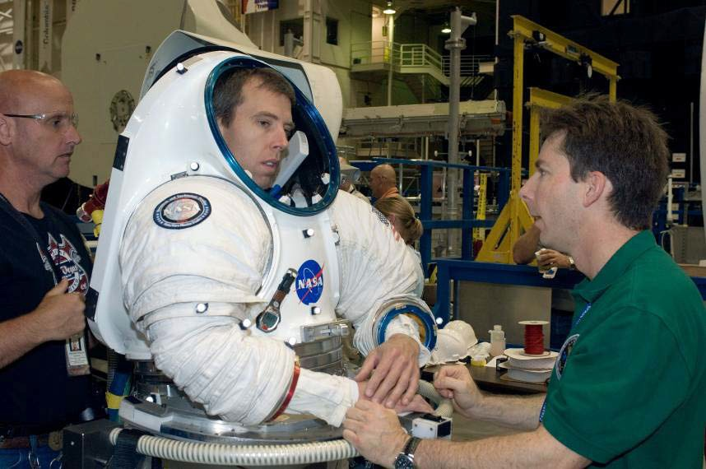
Figure 1: NASA Surgeon, Dr. Jeff Jones (right), and suit technician, Bill Welch (left), assist Astronaut, Andrew J. (Drew) Feustel, as he dons a Mark III advanced space suit.

Because spaceflight is physically challenging, the flight surgeon will assess the astronaut’s health before a flight, also known as preflight, to determine if the crew member is healthy. During the preflight phase of a mission, the flight surgeon will perform a physical examination of the astronaut. He or she will use pre-existing data to determine the astronaut’s preflight condition and to predict how the astronaut’s body will react in a reduced gravity environment.

One specific area of concern is bone density, which is a measure of how strong the bone is. Bone density is measured by the amount of mineral in a skeletal area, and this measurement is called Bone Mineral Density (BMD). BMD is measured with an instrument called a Dual-energy X-ray Absorptiometry densitometer (DXA), which uses x-rays to transmit photons through the body. DXA detects the different energies of the photons as they are absorbed differently by hard vs. soft tissue.
These energy levels are used to determine the BMD of hard bone tissue. Different groups of people lose BMD more rapidly than others. On Earth the rate of bone loss for elderly men and women ranges from 1% to 1.5% per year, whereas the rate of bone loss for an early postmenopausal woman could be 2-3% per year. A person may also lose BMD more rapidly at one site, e.g. the spine, than at another site in the body.
Bone loss increases when the human body is in a reduced gravity environment. Astronauts on the ISS, or on a future long-duration mission, may lose an average of 1% BMD per month while in space. An astronaut’s bones may weaken in a way similar to osteoporosis. Osteoporosis is a condition in which bones have lost minerals, especially calcium, making them weaker, more brittle, and susceptible to fractures. The risk of fracture for an astronaut may increase after the astronaut returns to Earth’s gravitational pull of1 g. The flight surgeon must continue to monitor the astronauts once back on Earth to make sure their BMD is regained through proper diet and exercise.

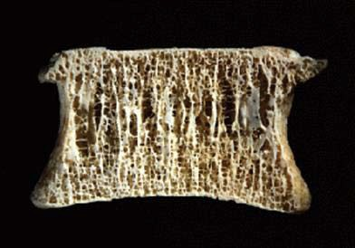
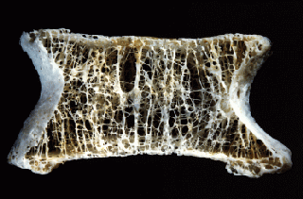
Source: Mosekilde, L. Z rheumatol 2000;59:Suppl 1:1-9

Figure 1: Normal bone on left compared to osteoporotic bone.

Instructional Objectives
- You will explore slope and the effects of a change of slope;
- You will recognize slope and y-intercept from key words;
- You will identify the y-intercept and interpret its meaning in a real world situation;
- You will write linear equations in slope-intercept form;
- You will calculate values using percent and proportional relationships;
- You will solve linear equations; and
- You will create tables from words.

Comparing Bone Loss on Earth and ISS

Directions: Answer questions 1 – 6 in your group. Discuss answers to be sure everyone understands and agrees on the solutions. Round all answers to the nearest tenth.

Problem
In the reduced gravity environment of the International Space Station (ISS), the average Bone Mineral Density (BMD) loss is approximately 1% per month compared to the average loss of approximately 1% per year on Earth. Researchers would treat this loss of BMD as a constant loss per month. The BMD would be measured preflight and then again at the end of 6 months. The difference between the two measures would be divided by 6 to get the average amount of bone loss per month. To get an average rate of loss, divide the amount of bone loss in a month by the initial BMD. This ratio may be expressed as a fraction, decimal, or percent. This number as a percent is the average percentage of loss each month. The unit of measure that is used for BMD is mg/cm².
Astronaut 1 is preparing for a mission to the ISS. As part of that preparation, the flight surgeon performs a preflight examination which includes a bone density test. The test results of the astronaut reveal a beginning BMD of 1050.0 mg/cm². The flight surgeon creates and uses tables to determine what effects the mission could have on the skeleton. Assume for this problem that no exercise or supplements are being prescribed.
- If 1050.0 mg/cm² is the preflight BMD of Astronaut 1, how much BMD would Astronaut 1 typically lose after one year on Earth?

- Suppose that Astronaut 1 loses the same amount of BMD found in question 1 each year for 5 years on Earth. Complete Table 1 to show the BMD each year. Use t for time in years and d for BMD in mg/cm². Round to the nearest tenth.

Table 1: Bone Mineral Density (BMD) of Astronaut 1 on Earth
Time, t (years) BMD, d (mg/cm²)

Preflight (0)
1
2
3
4
5

- If we assume that BMD loss continues at a constant amount per month in a reduced gravity environment, what is the amount of bone mineral density that would be lost after one year on the ISS if the beginning BMD for Astronaut 1 was 1050.0 mg/cm²?

- Suppose that Astronaut 1 loses the same amount of BMD found in question 3 each year for 5 years on the ISS. Complete Table 2 to show the BMD loss for each year. Use t for time in years and d for bone mineral density in mg/cm². Round to the nearest tenth.

Table 2: Bone Mineral Density (BMD) of Astronaut 1on the ISS

Time, | t (years) | BMD, d | (mg/cm2)
0
1
2
3
4
5

- On average, at what rate is the BMD for Astronaut 1 changing each year on Earth?

- On average, at what rate is the BMD for Astronaut 1 changing each year on the ISS?

Directions: Answer questions 7 – 13 in your group. Discuss answers to be sure everyone understands and agrees on the solutions. Round all answers to the nearest tenth.

- Use Tables 1 and 2 to find the difference in BMD after 3 years on Earth and 3 years on the ISS. What percent of the initial BMD does each difference represent? Round to the nearest whole percent.

- Do the relationships between time and BMD on Earth and the ISS represent linear functions? Explain your answer.

- How do these rates of change on Earth relate to slope? Is this also true on the ISS?

- What are the coordinates of the first ordered pair in Table 1?

- What do the coordinates in question 10 represent about the astronaut?

- The first ordered pair in Table 1 represents what feature of the graph?

- In slope-intercept form write the equations that represent the relationship between time and BMD on Earth and the relationship between time and BMD on the ISS. Use t for time in years and d for BMD.

Note: Students may graphically represent these equations using an online graphing tool or a piece of graph paper.

CAPSTONE PROJECT: TRIP TO MARS

Directions: Answer questions 14 – 16 in your group. Discuss answers to be sure everyone understands and agrees on the solutions. Round all answers to the nearest tenth.

- A 20% loss in BMD is the most any person can lose before being prone to breaks. If the BMD of Astronaut 1 before flight is 1050 mg/cm², what would the BMD be after losing 20%?

- Use the equation from question 13 to determine the time in years and months the astronaut can remain on the ISS before reaching the minimum BMD that was found in problem 14.

- Should Astronaut 1 remain on the ISS or go on an extended trip to Mars for 3 years without supplements or an exercise regime? Explain your answer.

CAPSTONE PROJECT: TRIP TO MARS

Directions: Answer questions 17 – 21 independently. Round all answers to the nearest tenth.

- Astronaut 2 is preparing for the same mission to the ISS. The flight surgeon found the initial result of the BMD test was 1000 mg/cm². Write an equation that would represent the BMD of Astronaut 2 on ISS for 1 year. Use d for bone density and t for time in years. Remember bone density loss on the ISS is 1% per month.

- Astronaut 2 is scheduled to remain on the ISS for 6 months. Will Astronaut 2 reach the minimum allowable bone density (20% loss in BMD) within that 6 month time frame? Hint: t is in years.

- Compare the ISS bone density equations for Astronaut 1 and Astronaut 2. Explain the differences.

- What are some key words in this problem that help you to identify slope?

- What are some key words in this problem that help you to identify the y-intercept?

